Team project

Project name: First Words

Team name: 2A

Team members: Panarina Alexandra, Turbayeva Ainash

This application will help kids in learning of new words. This game will be very helpful for parents and their young children who only learn to speak.

Gathering requirements

1. Functional requirements
2. Application must allow user to choose language of content (Russian or Kazakh);
3. Application must allow user to choose one from two options (‘Choose picture…’ or ‘Show where…’);
4. Application must allow user to choose category of words (‘Animals’, ‘Food’, ’Home’, ’Toys’);
5. Application must allow user to go back at the application trace;
6. Application must allow user to get response by audio format;
7. Non-Functional Requirements
8. Application must allow user to get response in appropriate time;
9. Application must be available at any time after downloading with and without internet;

Description of the application

Use cases

1. Title: Choose picture
2. Actor: User-kids, user-parent
3. Scenario: User-parent chooses language of content. User-parent chooses option ‘Choose picture…’ and category of words (‘Animals’, ‘Food’, ’Home’, ’Toys’). User-kids choose picture and then get response in audio format, where application voices the name of picture.
4. Title: Show where
5. Actor: User-kids, user-parent
6. Scenario: User-parent chooses language of content. User-parent chooses option ‘Show where…’ and category of words (‘Animals’, ‘Food’, ’Home’, ’Toys’). User-kids gets names of picture and should choose right one. Then user-kids has response in audio format, is he/she right or not.

User stories

As a… user-parent

I want… to teach children new words in easy and funny way

So that… I don’t need to buy teaching toys and books

As a… user-kids

I want… to learn new words in colorful way

So that… visualization is a good tool to remember and learn

Mockup

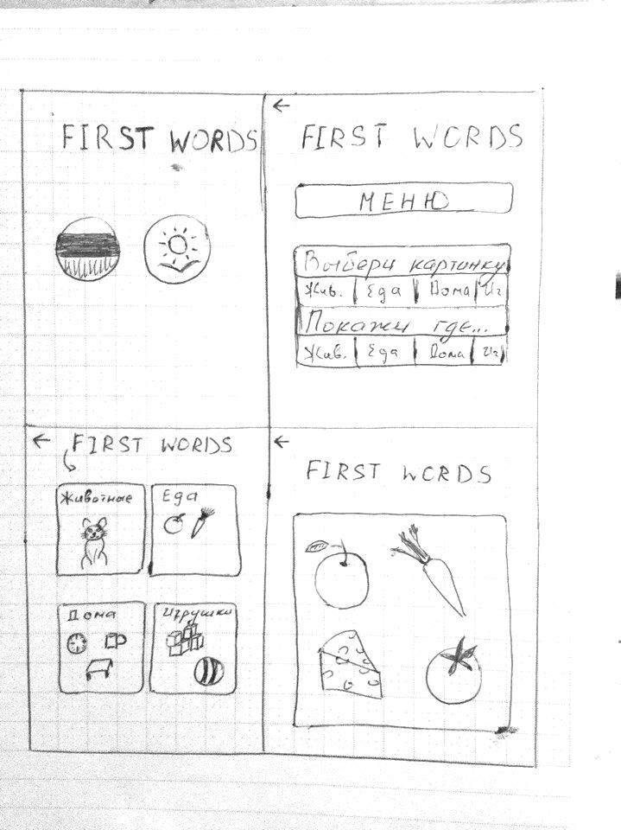

Figure 1

Identification of the main objects (classes)

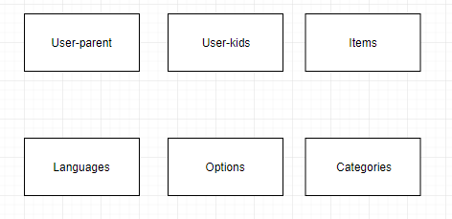

Figure 2

Describing the Interactions between objects

Conceptual object model

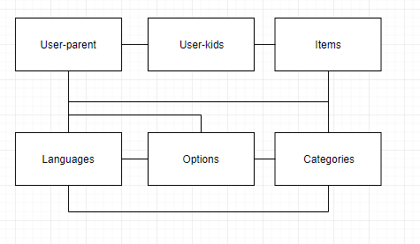

Figure 3

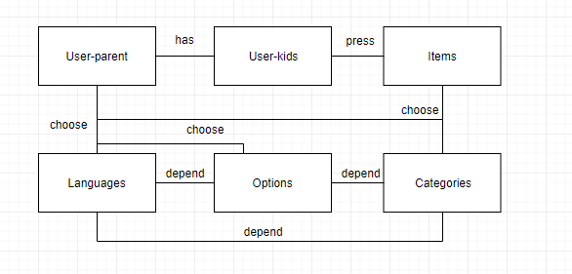

Figure 4

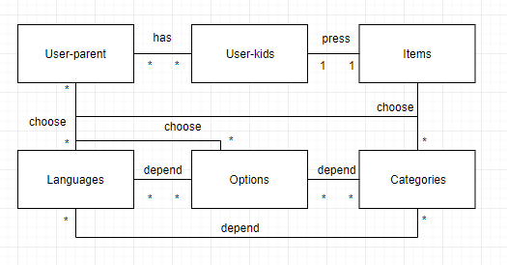

Figure 5

Creating a Class Diagram

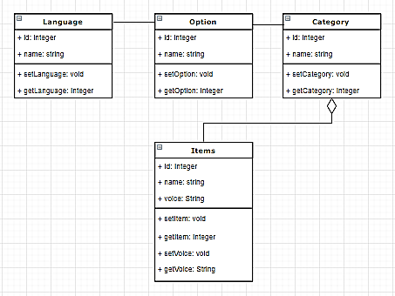

Figure 6